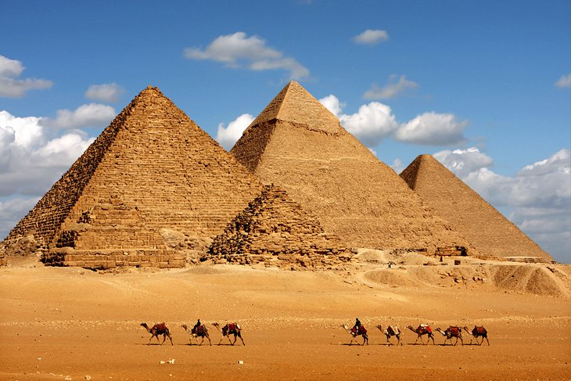

6 DAY 5 NIGHTS ''THE GREAT PYRAMID EGYPT'' TOUR
6 天 5 夜 ''埃及伟大金字塔'' 之旅
GROUND ARRANGEMENT | (T/C: GA-TGPET) PRIVATE | UPDATED: 03JAN2022

Day 1- Arrival Cairo Airport 44.8km– Hotel - Dinner
Upon arrival Cairo international airport, you will be welcomed by our representative and transfer to hotel.
抵达开罗国际机场后，我们的代表将迎接您并转移到您的酒店。

Day 2- Cairo- 21kmGiza Pyramids- Sphinx- the Egyptian Museum- (Breakfast/Lunch/Dinner)
After breakfast start our guided tour to visit the Giza Pyramids, Sphinx. Today there are more than 93 Pyramids in Egypt; but the three main Pyramids are in Giza Plateau, which were built in the 4th Dynasty (circa 4650 B.C). The Pyramids of Ancient Egypt were built as tombs for Kings (and Queens), and it was the exclusive privilege to have a Pyramid tomb. the most famous ones are those at Giza, The Great Sphinx, or as the ancients knew it, “ShesibAnkh” or “the living image”, has to be one of the most recognizable constructions in history. Stop by a Papyrus institute where can find how the ancient Egyptians used the papyrus for writing and can buy some souvenirs for your friends After lunch, will continue our tour to the Egyptian Museum of Antiquities the Egyptian Museum (built in 1902) is home to an extensive collection of ancient Egyptian antiquities. It has 120,000 items, with a representative amount on display, the museum contains many important pieces of ancient Egyptian history. It houses the world’s largest collection of Pharaonic antiquities, and many treasures of King Tutankhamen. the remainder in storerooms. Stop for having tea at a Perfume factory where scents made from lotus flower, papyrus or jasmine oil. These fine perfumes need equally fine glass bottles to enjoy the oriental scents witch you can find Only in Egypt
早餐后开始我们的导览游,参观吉萨金字塔和狮身人面像.今天埃及有超过 93 座金字塔: 但是三个主要的金字塔都在吉萨高原, 它们建于第四王朝 (大约公元前 4650 年). 古埃及的金字塔是为国王(和王后)建造的陵墓,拥有金字塔陵墓是一种特权.最著名的是吉萨的那些，大狮身人面像,或者如古人所知 “ShesibAnkh” 或 “活生生的形象”, 必须是历史上最知名的建筑之一.参观纸莎草纸研究所，在那里可以了解古埃及人如何使用纸莎草书写，并可以为您的朋友购买一些纪念品午餐后,将继续我们的埃及博物馆埃及古物博物馆埃及博物馆建于 1902 年）是拥有大量古埃及文物.它有120,000件物品. 具有代表性的展出数量,博物馆包含许多重要的古埃及历史作品.它拥有世界上最大的法老古董收藏品, 以及图坦卡蒙国王的许多宝藏. 其余在储藏室.在香水厂停下来喝茶, 那里有莲花, 纸莎草或茉莉油制成的香味. 这些精美的香水需要同样精美的玻璃瓶来享受只有在埃及才能找到的东方香味.

Day 3- Citadel of Saladin 31.9km- Mohamed Ali Mosque- Azhar & Hussein Mosques (Breakfast/Lunch/Dinner)
After breakfast, tour visiting the Citadel of Saladin & Mohamed Ali Mosque the Citadel is a medieval Islamic fortification. Proceed to visit Al Azhar Mosque. There are hundreds of old mosques to visit in Cairo, there is none that can compete with Al-AzharMosque in standing and importance to the history of Islam. Continue to Hussein Mosque which near the Khan El-Khalilibazaar. It is named for the grandson of Muhammad, Husaynibn Ali, the mosque, considered to be one of the holiest Islamic sites in Cairo, was built on the cemetery of the Fatimidcaliphs, a fact that was later discovered during the excavation. Will end our tour by free time for shopping at Khan Khalili Bazar, the largest Bazar in Middle East this Market is famous for its unusual, typical oriental souvenirs and handmade crafts. Medieval atmosphere of this traditional market gives visitors great pleasure and glimpse into what medieval markets were like: Cafes, restaurants, shops Then you will be transferred to your hotel, dinner and overnight.
早餐后，参观萨拉丁城堡和穆罕默德阿里清真寺城堡是中世纪的伊斯兰防御工事。继续参观爱资哈尔清真寺. 开罗有数百座古老的清真寺可供参观，没有任何一座清真寺在地位和对伊斯兰教历史的重要性方面可以与爱资哈尔清真寺相媲美.继续前往靠近 Khan El-Khalilibazaar 的侯赛因清真寺. 它以穆罕默德的孙子侯赛尼本阿里命名, 这座清真寺被认为是开罗最神圣的伊斯兰教地之一,建在法蒂玛哈里发的墓地之上, 这一事实后来在挖掘过程中被发现。将在空闲时间结束我们的旅行, 在中东最大的巴扎尔汗哈利利巴扎尔购物, 这个市场以其不寻常的, 典型的东方纪念品和手工工艺品而闻名. 这个传统市场的中世纪氛围给游客带来了极大的乐趣和一瞥中世纪市场的样子:咖啡馆,餐馆,商店然后您将被转移到您的酒店,晚餐并过夜.

Day 4 - Cairo – 208km-Alexandria – Cairo- (Breakfast/ Lunch/Dinner)
Alexandria is the second largest city and the second largest metropolitan area in Egypt after Greater Cairo by size and population, extending about 32 km along the coast of the Mediterranean Sea in the north central part of the country Alexandria was founded around a small Ancient Egyptian town. Tour visiting the Fort of Qaitbay, is a 15th-century defensive fortress located on the Mediterranean Sea coast, and was established in 1477 AD by SultanAl-AshrafSayfal-Din Qa'itBay. The Citadel is situated on the eastern side of the northern tip of Pharos Island at the mouth of the Eastern Harbor. Proceed to the Mosque of El-MursiAbul-AbbasMosqueThe mosque is dedicated to the 13th century AlexandrineSufisaintel-MursiAbulAbbaswhose tomb it contains. Itis located in the Anfoushi neighborhood of Alexandria, near the Citadel of Qaitbay. The Mosque was redesigned and built-in today's current form by Eugenio Valzania and Mario Rossi in the years 1929/1945.After lunch drive to Montazah Gardens that surrounds the Montaza Palace the summer residence of late king Farouk. It was built on a low plateau east of central Alexandria overlooking a beach on the Mediterranean Sea.
亚历山大是埃及第二大城市和第二大都市区,按面积和人口计算,仅次于大开罗,沿该国中北部的地中海沿岸延伸约 32 公里 亚历山大建立在一个古埃及小镇周围.游览 Qaitbay 堡垒,这是一座 15 世纪的防御堡垒, 位于地中海沿岸, 由 SultanAl-AshrafSayfal-Din Qa'itBay 于公元 1477 年建立. 城堡位于法罗斯岛北端东侧，东港入海口. 继续前往 El-MursiAbul-Abbas 清真寺清真寺清真寺是献给 13 世纪的 AlexandrineSufisaintel-MursiAbulAbbas 的,它所包含的陵墓.它位于亚历山大的 Anfoushi 社区,靠近 Qaitbay 城堡. 清真寺在 1929/1945 年由 Eugenio Valzania 和 Mario Rossi 重新设计并建成了今天的形式. 午餐后驱车前往蒙塔扎宫周围的蒙塔扎花园,这里是已故国王法鲁克的夏宫.它建在亚历山大港中部以东的一个低高原上, 俯瞰着地中海的海滩。

Day 5 - Shopping and Nile Cruise Dinner
After breakfast last day for shopping, where you will be taken to the biggest shopping mall in Cairo and Crystal products show room. In the evening will embark the Nile cruise for dinner and entertainment show including belly dance, folkloric show and enjoy the open buffet dinner, then will be transferred to the hotel.
最后一天的早餐后购物,您将被带到开罗最大的购物中心和水晶产品展示.晚上将乘坐尼罗河游船享用晚餐和娱乐表演, 包括肚皮舞, 民俗表演和享用开放式自助晚餐, 然后转移到酒店。
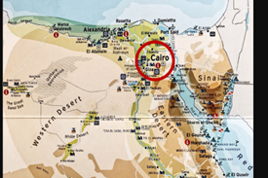
Day 6 – Departure Home
After breakfast, you will be transferred to Cairo airport for final departure.
早餐后,您将被送往开罗机场,最后离开。

Hotel | Travelling Period: Valid 01 Jan 2022- 30 Apr 2023
 | GV2-3 | GV4-6 | GV7-9 | Single Supp add on. | Extension Night With  Breakfast & Transfer  （Per Room Per Night Cairo）
 |  |  |  |  | TWIN | Triple
5 Nights 4 * Pyramid Parks Resort or similar | 2598 | 2198 | 1898 | 469 | 780 | 1018
Hotel Surcharge: Ester/Christmas/N. Eve  15-22Apr & 20 Dec 2022 till 1- 5 Jan 2023 & 07-14 Apr 2023 | 3018 | 2618 | 2318 | 570 | 888 | 1178
5 Nights 5 * Grand Nile Tower or similar | 2998 | 2598 | 2298 | 788 | 1090 | 1410
Hotel Surcharge: Ester/Christmas/N. Eve  15-22Apr & 20 Dec 2022 till 1- 5 Jan 2023 & 07-14 Apr 2023 | 3528 | 3128 | 2828 | 910 | 1278 | 1798
Tour Included:
Exclusive Arrival Transfer with Private vehicle.
- 05 Nights’ Cairo Accommodation as above.
- Meals as per itinerary -Daily Breakfast+ 04 Lunch+ 05 Dinner + mineral water during lunch and dinner.
- Transfers and tours as per itinerary.
…………………………………………………………………………………………………………………
Remarks:
- Prices are quoted per person in Ringgit Malaysia (MYR) & subject to change without prior notice.
- Tipping per pax RM440/pax for a whole Stay Tour.
- Above ground arrangement (GA) only.
- Professional English-Speaking Guide for a whole Stay.
- Non-refundable deposit of RM 1000/pax upon booking confirmation.
- Hotel rooms are subject to availability/ similar accommodation will be provided
- Travel and Health Insurance Not include.
- Compulsory surcharge New Year dinner on 31 Dec RM522 (4*) -RM 780 (5*) /Person
- Child under 12 years reduction 50% from adult rate if sharing room with 2 adults
- 1 adult + 1 CHD at same room will be charged as 2 adults.
- visa is not required.
Covid-19 current regulations to enter Egypt (will update if any changes)
- If anybody had the vaccine (two doses) NO need to do the PCR test before arrival to Egypt but must bring the certificate that he/she had the two times vaccine and this certificate must have the QR Code and 2nd dose not less than 14 days prior arrival date.
- If anybody had the vaccine for one time only (1st dose) so must get a negative PCR test (with QR code)72 hours prior arrival
- No PCR tests are required to travel from one city to another or for domestic flights
- No quarantine is required
